Lab 2 Akshit Wadhwa

Activity 1
For the two products (Like and Dislike) that you chose in Lab 1:
- List down the Usability Goals, the two products meet or fail to meet (Usability Goals are on Slide 18, Lecture 1). Also explain how?

- Effectiveness – The monitor provides accurate performance with a high refresh rate and precise colour correction, making it suitable for gaming, coding, media editing, and general tasks. Being a high display screen, it should have a high refresh rate, and the color correction of the display
- Efficiency –The display is easy to use with functional ports (USB-C, HDMI, etc.) and an ergonomic size. Power delivery via Type-C is optimized so it does not negatively impact connected devices. Should be accurate for the tasks it is supposed to perform such as gaming, coding, media etc.
- Safety –The monitor minimizes eye strain through flicker-free lighting, blue light filters, and glare reduction. It maintains consistent performance (refresh rate, brightness) even during long-term use.
- Utility –It supports multiple devices (Macs, laptops without HDMI ports, etc.), provides rotation and pivot options, and enables multitasking on widescreen displays.
- Learnability – The on-screen display (OSD) is intuitive, allowing easy customization of brightness, colour modes, and presets. Assembly is straightforward with a clear user manual. After coming out from the box, if should have easy assembling as well as well-defined user manual.
- Easy to remember how to use – The monitor shouldn’t have difficult user interface, and user should know how to change the settings even after not using it for a long time.
- Enjoyable – It should be enjoyable to use for the customer, be it for long time use or for short term use.

For the Product I disliked which is a Microsoft Controller,
- Effectiveness -- Delivers accurate inputs with responsive buttons, triggers, and analogue sticks, making it reliable for most games but sometimes it still suffers from issues like analogue stick drift after heavy use and lacks the precision of newer input technologies.
- Efficiency -- Ergonomic design supports long gaming sessions, and wireless/Bluetooth connectivity ensures smooth, low-latency gameplay. Still to charge the controller , it lies on old AA batteries which feels outdated as compared to build in rechargeable batteries.
- Safety – It has a comfortable design as compared to the other controllers in the market made by Sony or third party vendors. It also has an ergonomic design which makes it comfortable to use in the long run.

- Utility -- Missing modern features like advanced haptics, adaptive triggers, motion sensors, or integrated speakers/mics that competitors offer. Otherwise it is still reliable with headphone jack as well as customizable button mapping.

- Learnability – Standard button layout is intuitive, making it easy for both new and returning users. Plug-and-play simplifies setup.

- Memorability – Consistent design across Xbox generations makes it easy to remember and return to, even after long breaks. However, this consistency also shows how little innovation has occurred — the layout and feel have barely changed since the Xbox 360 era.

- Satisfaction / Enjoyment – The Xbox controller remains reliable and familiar, but it’s built on legacy design choices (AA batteries, basic rumble motors, minimal innovation). While competitors like Sony and Nintendo push forward with new input technologies, Microsoft has chosen to prioritize consistency and comfort over innovation — which is why some see it as “still using old technology.”

- List the User Experience Goals, which your chosen products satisfy.

- For the product I like which is computer monitor , it satisfies the goals such as Fun(due to its high and smooth refresh rates) , engaging , helpful(due to its built in features such as eye care) , Supporting creativity and entertaining (for streaming movies games).Some undesirable aspects can be that some people find it invasive if the monitor has a built in camera/mic.
- The Xbox controller, while widely appreciated, also has several undesirable aspects from a user experience perspective. Some players find it frustrating due to occasional connectivity issues or input lag when using it wirelessly. The battery system—still relying on AA batteries in many models—can feel annoying and outdated, especially when competitors use built-in rechargeable options.

- For each Design Principle (Slide 22, Lecture 1), explain if your products satisfy or break them.
- Visibility—This design principle is both followed as well as broken depending on the monitor, in some models the power buttons as well as the other control buttons are visible with led indicators. In some models, the buttons are on places which are not easily accessible.
For the Xbox Controller, it follows this principle clearly as all the buttons are led indicated as well as accessible with fingers to have a enjoyable gaming experience.

- Feedback – All monitors follow this principle as when the buttons of control are pressed in the monitor (for example to change the brightness or to increase the volume if the monitor has some speakers), there is a feedback input on the screen which confirms the change.
For the Xbox controller also if there is some feedback or registering some actions then if provides feedback through vibration, trigger resistance and led indicators. The only break in this is that when the controller is out of range or not connected, no feedback or haptic response is generated.

- Constraints—The ports and the stands in the monitors are all shaped uniquely, but the back panel for all the monitors are same which leads to it easily being connected to a monitor arm or a stand which is flexible to move. Incorrect connections are also displayed in the monitor with a on screen notification.
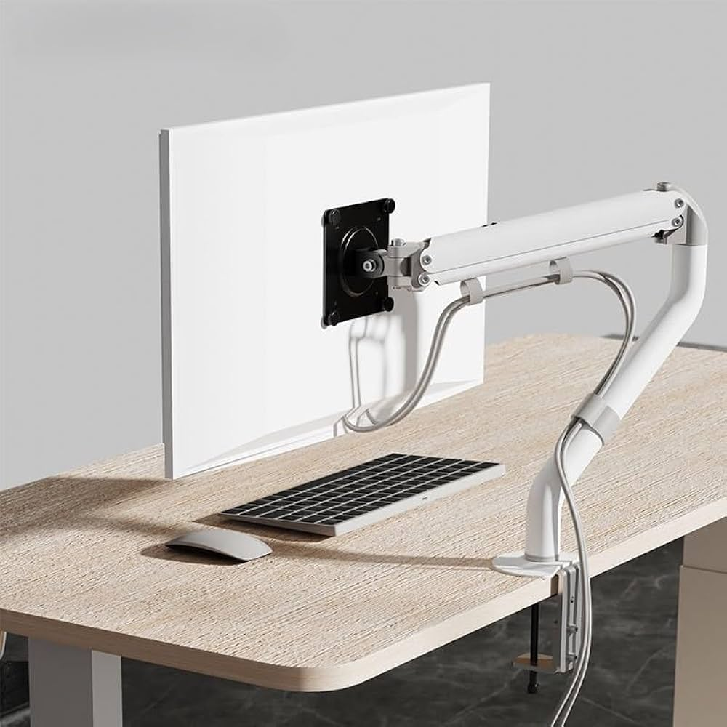
For the Xbox controller, the buttons are always in the same font as well as in same style , triggers have limited travel which leads to less physical strains.

- Consistency – Most brands in the monitors contain consistent layout and design for the same model of design as well as button behavior so if the person is upgrading to the newer model, he/she doesn’t face difficulty to learn the new design. This is sometime broken if the company changes their regular design and opts to launch a newer model.
In the Xbox, sometimes the consistency will break if the design of the touch pad or the annotations of the touch pad is changed along with the addition of some new buttons.
- Affordance – The design of the monitor as well as the buttons on the controller should not be awkward so that it defies the principle which it was made for. For the controller , the pressing actions of the buttons should be soft and consistent.

Activity 2
Explain at least two Dark (or Deceptive) Patterns that you have personally experienced. The Dark Patterns can be for digital or non-digital products.
Screenshots/photos of the products will be useful to show and explain.
One major example these days for dark as well as deceptive pattens is that of the quick commerce websites such as Zepto as well as Blinkit where the customers are first called in the app with the lure of heavy discounts such as 100 off, 150off ,30 percent off etc. But when the customer opens the app , it is told that these offers only apply if the cart value is above some cost such as 499, 399. In such cases the person has to order things which he doesn’t want which leads to a profit for the company.
Another can be that if the person puts the amount mentioned into the cart by completing the required checkout price, then there are some “Platform Fee” or “Small Order Fee” added — reducing the actual benefit.
The exploits the meaning of the discount with hidden charges appearing at the end. Thus causing a Dark or deceptive patterns.

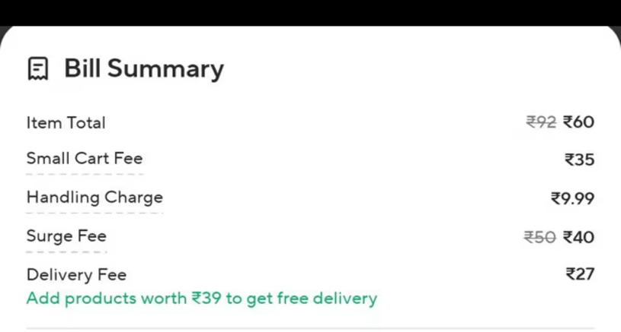

Activity 3
Take one physical product and one digital product and indicate the Affordance and Signifiers it possesses. Show photos/diagrams. Avoid products which are extremely common.

The physical product that indicates affordance and signifiers is Amazon Alexa or any other voice commanding smart device. Home pods and goggle echo are also the part of such list. Here the affordance is that the person can keep it stable on a table or a flat surface and operate it using voice commands as well as manual touch commands on the device. The device can be activated manually using voice command such as changing the song, increasing the volume, fast forwarding a voice. Some devices also have a screen where a person can play movies, seeing video titles and be same to a phone but more stable kept and more easily accessible using voice command.
Affords toggling the microphone on the device physically as well as manually.

Now the Signifiers on this device can be that when you say the keyword to activate the device which is “Alexa”, “Ok goggle”, “Hey Siri”, there is a smart light ring which pops up on the device. This signifies that the device has been activated and the next command which you will say, it will listen to it. Other types of light ring such as red ring also are there which indicate that the microphone is muted of the device or green light indicate that the volume is zero.

One common digital product can be Figma, which is a website/ app designing platform. This combines visual cues as well as interactive features to make such designs from the base using small components which are same to the actual device/platform it is meant for.
Affordance features such as dragging/importing images, using different styles and fonts to make your own resized elements. There are also some pre stored templates which the person can use for formatting it into its own style.
The signifiers are how the app provides some clues as well as indicators to tell what has happened or needs to be done.
Some example of this in Figma is that when you select some element on the screen there is a white layout screen around it to indicate that you have selected that element. If the element is clickable, then that is also indicated which a mark.
Changing the size and the position of the certain element is also easy as when you select that elements buttons for both are displayed below it.

